**Smectic Film Thickness Estimator (SFTE) Code Usage and Principles**

Keith G Hedlund

University of Colorado Boulder Department of Physics

Soft Materials Research Center

May 14th, 2020

**Principles**

The Smectic Film Thickness Estimator (SFTE) is software that analyzes an image of a smectic film and predicts its thickness by comparing the color information from the camera with a theoretical model. This program uses an algorithm developed by Hiroshi Yokoyama and Wei Chen of Kent State University in 2020 [1]. Their paper lays out a method for rapidly determining the thickness of a smectic film based on the normalized color information. The equations and principles are described in detail in the paper, so we’ll largely skip over them here. What is important to know is that the image is split by the camera into red, green, and blue channels, so that each pixel of the sensor provides a triplet of intensities representing the color of that pixel. Each of these three values represents the intensity of light within a certain range of wavelengths, and together the three values represent the spectrum of visible light at that pixel. The function that the camera uses to split the incoming wavelength of light into three color channels depends entirely on the brand and type of camera and is not at all easy to determine. To get around this, SFTE takes the color channel triplet of a single pixel and compares it to an image taken using the same camera of a piece of black glass, which has a uniform reflectivity of 4% across the visible spectrum. This allows the measured intensity from the film to be translated directly into reflectivities of light with a given wavelength. These reflectivities are then compared to an ideal model for the film, which describes how the reflectivity for each color varies with the thickness of the film. This removes entirely the need to determine the camera’s mapping function and allows this method to be applied to any camera provided the appropriate black glass image and color normalization protocols are observed (see below). Instructions for making the plot of normalized reflectivities (Fig. 1b) are available in Hiroshi’s paper. The intersections of the theoretical plot with the measured values of reflectivity are then plotted, and a function identifies the set of red, green, and blue points which agree best on thickness. For the data shown in Fig. 3, this would be the second set of RGB values (circled in the figure), as they are the closest to being vertically colinear. This value of thickness is then reported by the program to the user.

Fig. 1: Plots of the predicted RGB values (top) and the normalized RGB values (bottom) as functions of thickness in nanometers.

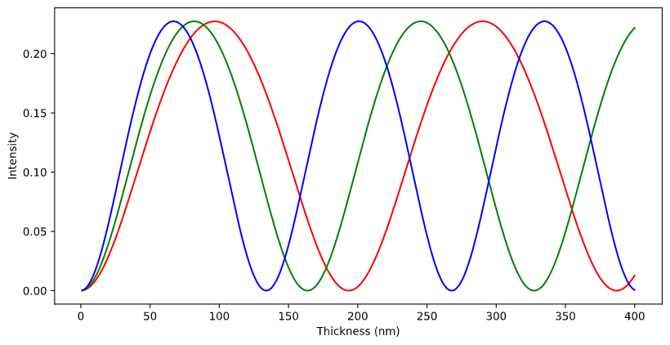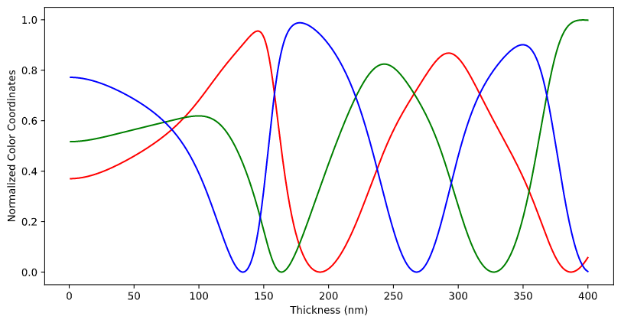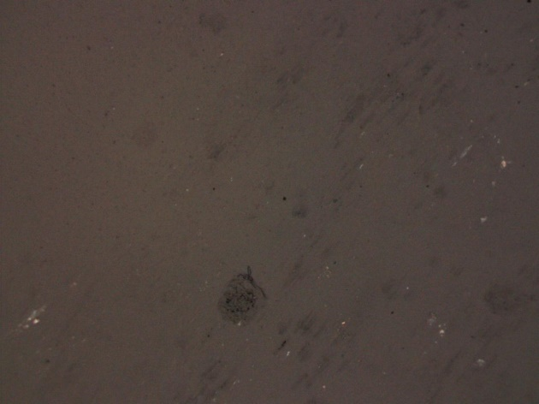

Fig. 2: Image of a piece of black glass. The dark patches are caused by small pits and scratches in the surface which are difficult to avoid. The intensity should be measured within an area that doesn’t include one of these dark patches.

Fig. 3: Plot showing the intersections between the normalized color plot in Fig. 1 and given RGB values extracted from an image of a film.

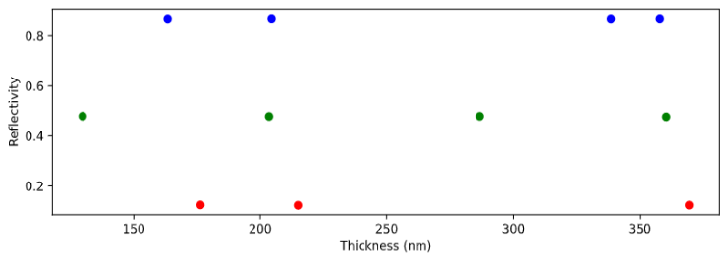

Several assumptions were made in converting Hiroshi’s approach to suit this project, the largest of which being the wavelengths of light which characterize the red, green, and blue channels. These values are initiated in the header of the program and are labelled Lr, Lg, and Lb, respectively. These values are integral in producing the color plots seen above, and physically represent the wavelength to which each color channel of the camera has the highest sensitivity. These values were chosen based on non-camera specific data and should be improved based on the camera being used in a specific experiment. To do this, images of several shades of red should be taken with camera and compared with spectrograph data of the same shades to find which wavelength of light produces the highest pure-red channel response, and likewise for green and blue.

It was also assumed that the index of refraction of the material stays constant as the temperature increases, and that the light illuminating the film is non-polarized. If polarized light were being used, the birefringence of the material would also need to be considered. The error caused by these two assumptions is, in most cases, negligible. However, if the material being used shows large changes in refractive index as the temperature changes or if polarized light is being used, SFTE may introduce much larger errors into the thickness measurement.

**Usage**

The code for SFTE is annotated in many places with instructions on how to use it, but this assumes that the coding environment is already set up. The program itself, titled “Calculating Film Thickness from Colour Information.ipynb” is a Jupyter notebook, so at a bare minimum Anaconda and Jupyter must both be installed. The code was written entirely in VSCode, so this is the recommended environment for running and modifying the program. The required packages for the program are numpy, matplotlib, matplotlib.pyplot, math, pandas, colour, openCV (cv2), and colour.plotting. Ensure that all of these are installed in the Python coding environment before running the program. Once the environment is properly set up, the variable titled “prefix” should be changed to match the data path of the folder which the image is located in. Right below the “prefix” variable, there will be a variable “fileName”; this is the variable which represents the image throughout the code, so the part inside the quotes should be changed to match the name of the image file.

After specifying the image to be analyzed, a black glass reference image must also be specified. Scroll down to a little bit below where the image to be analyzed was added, there will be a cell that initializes a variable called “referenceName” in the same manner as the previous image. Replace the section in quotes with the name for the appropriate black glass image. By default, this black glass image is assumed to be in the same folder as the image being tested.

It is important that the black glass image being used was taken under identical lighting and microscopy conditions to the image being analyzed, otherwise the color mapping will not work! Once this image is specified, check to make sure all the material properties listed at the top of the program are correct for the liquid crystal being used; by default, they are the material properties for 8CB. If the material properties are not correct, they will need to be modified. Text

SFTE determines the color information of the film by averaging the red, green, and blue pixel data in a square area centered at the chosen coordinates. To change the size of the square area being sampled, change the variable “sampleRange” specified in cell 8 of the program. This variable represents the length in pixels of each side of the square sampling area. Text

The code can now be run. Two pop up windows will appear in sequence, and for each you must click on the area of the image you wish to measure. Note that the pop-up windows may appear behind the coding window, so check your taskbar to see if the pop-up has appeared as expected. For the black glass, the location chosen should be an area with no distortion or visible contamination. Samples of the recorded colors will be shown in the code. The program will then produce an estimate for the thickness of the film, visible at the bottom of the code below cell 13.

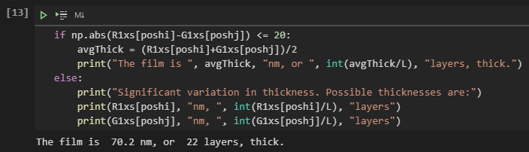

If the estimate produced is obviously not accurate, the program responds with “significant variation in thickness”, or returns an error, the range of possible film thickness for the theoretical plot may need to be increased or decreased. To do this, adjust the variable “rang” at the top of the program (cell 1) to modify the range in nanometers of possible thicknesses for the film.

The thickness of a film can often be estimated when working with the film in the lab: islands and droplets on a thinner film will generally move faster, thicker films usually require more material when being drawn, and it will be easier to see layer steps on thinner films especially under 30 layers. These characteristics as well as a general knowledge of the colors that films go through as thickness increases, shown below, is important for determining if the thickness reported by the program is accurate.



A qualitative plot of color versus thickness for smectic films. The actual film thicknesses which cause these colors depends intimately on the refractive index for the material, hence why it hasn’t been labelled on this image. For 8CB, the first major color shift from gray to yellow occurs at approximately 70nm.

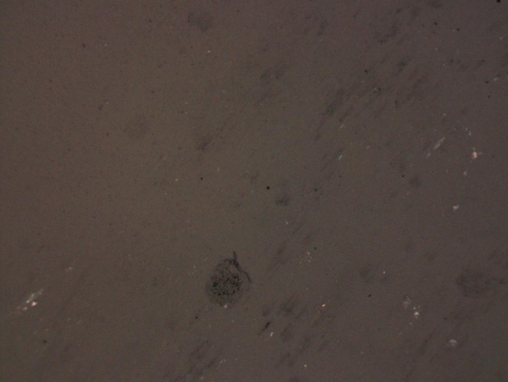Here is an example of a film image, black glass image, and some of the relevant outputs of the program:

The black glass reference image being used

The film being tested

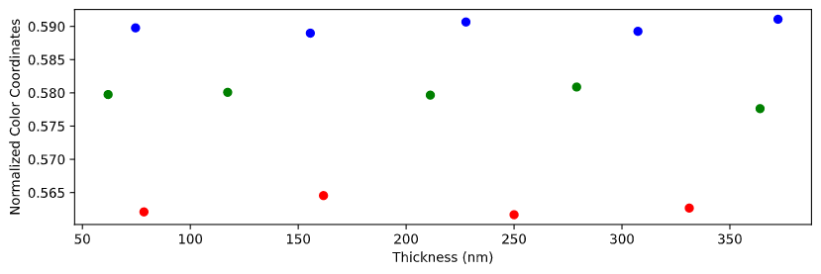

Intersecting normalized color coordinate values for each channel as a function of thickness.

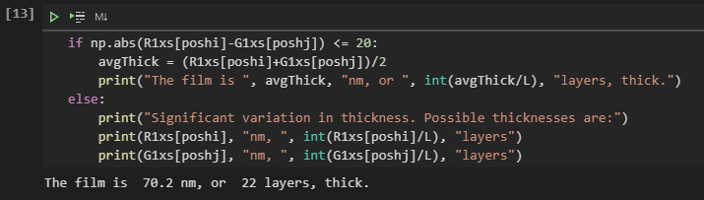

The reported thickness for this film is 70.2 nm, or 22 layers. This makes sense, as this film is right on the cusp between gray and yellow, which is known to happen at around 20 layers.